Question 1: Using the mapping procedure described in Fig. 7-3, give the first microinstruction address for the following operation code: (a) 0010;(b) 1011;(c)1111

Question 2: Formulate a mapping procedure that provides eight consecutive microinstructions for each routine. The operation code has six bits and the control memory has 2048 words.

Question 3: Using Table 7-1, give the 9-bit microoperation field for the following microoperations:

Question 4: The following is a symbolic microprogram for an instruction in the computer defined in Sec. 7-3.
a. Specify the operation performed when the instruction is executed.
b. Convert the four microinstructions into their equivalent binary form

Question 5: Add the following instructions to the computer of Sec 7-3 (EA is the effective address). Write the symbolic microprogram for each routine as in Table 7-2.
(Note that AC must not change in value unless the instruction specifies a change in AC.)

Question 6: Write a symbolic microprogram routine for the ISZ (increment and skip if zero) instruction defined in Chap. 5 (Table 5-4). Use the microinstruction format of Sec. 7-3. Note that DR = 0 status condition is not available in the CD field of the computer defined in Sec. 7-3. However, you can exchange AC and DR and check if AC = 0 with the Z bit.

Question 1:

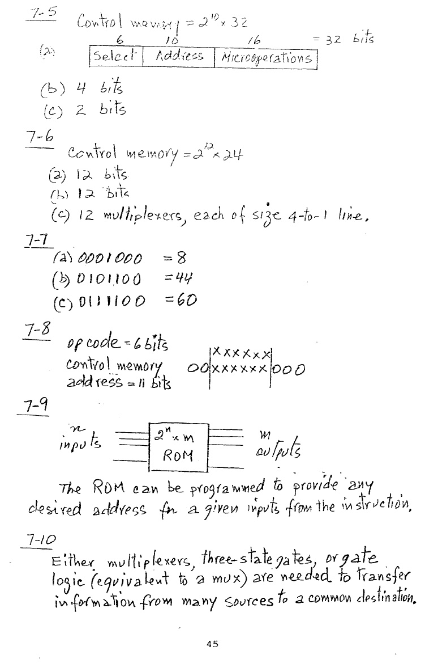

Question 2:

Question 3:

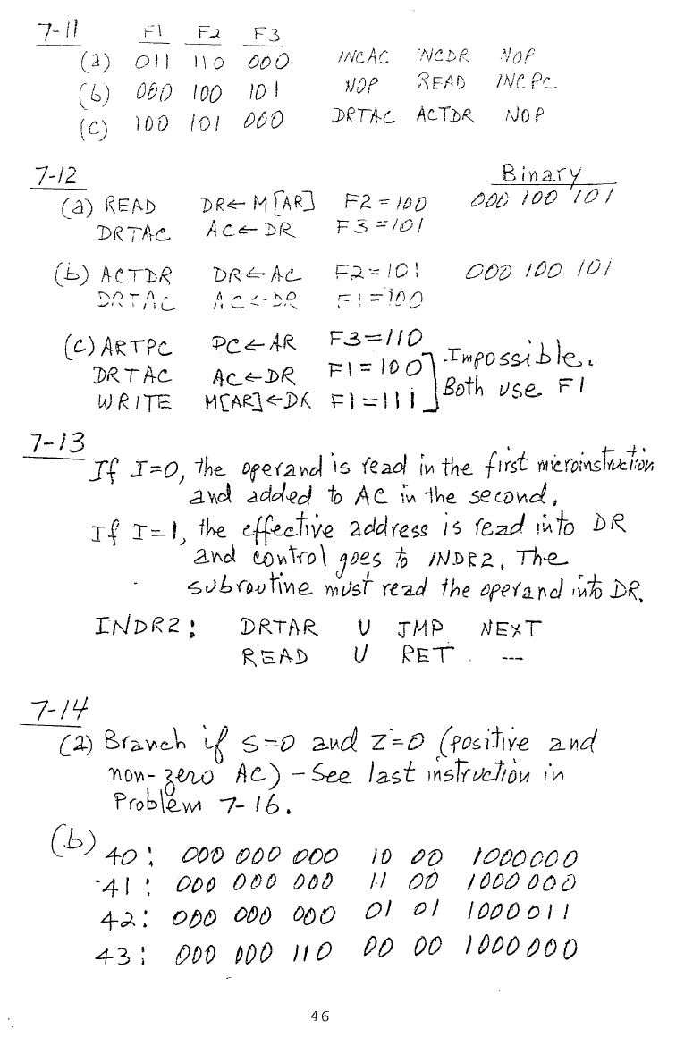

Question 4:
a)

b)
Address Microinstruction

Question 5:

